Data Collection Plan

PROJECT:
What questions do you want to answer?
What & Why
Data |  | Operational Definition and Procedures
What | Measure type/  Data type | How measured¹ | Related conditions to record² | Sampling notes | How/where recorded (attach form)
How will you ensure consistency and stability? |  |  | What is your plan for starting data collection? (Attach details if necessary, including length of your data collection period.)  How will the data be displayed? (Sketch on additional sheet.)

Desired Data Characteristics

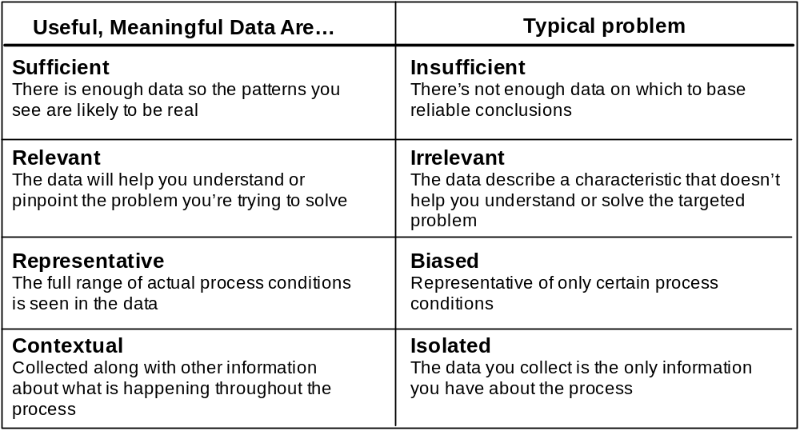

Desired Measurement Characteristics
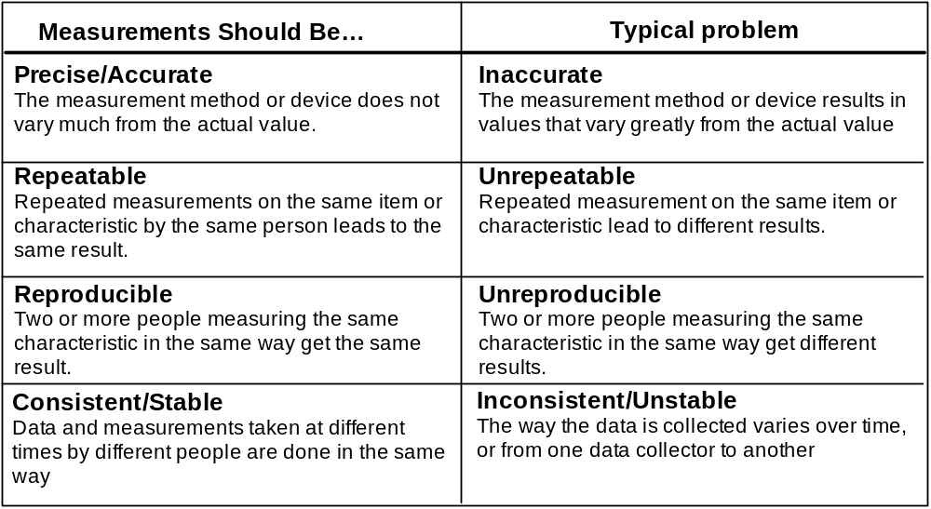

Examples of Data
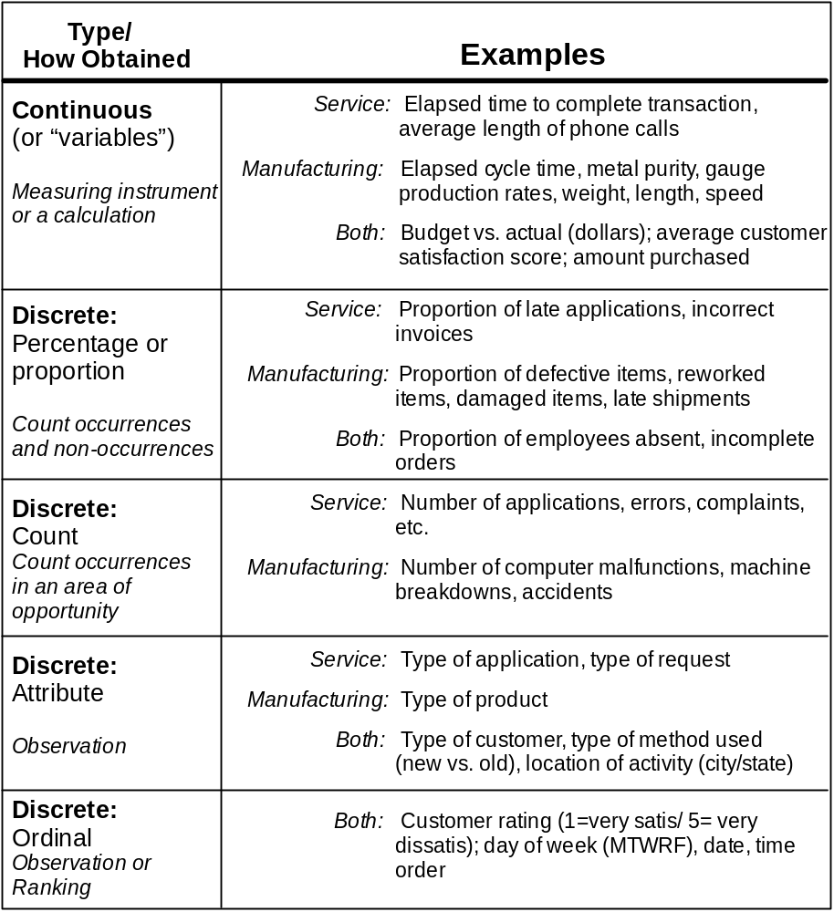

Distinguishing Between Continuous, Percentage, and Count Data
